Experiment No. 2

Title: Unit testing

Batch: B–1 Roll No.: 16010422234 Experiment No.: 2

Aim: To perform unit testing using JUnit/PyTest.

Resources needed: Java, JUnit / Python, PyTest

Theory:
Unit Testing in Python is done to identify bugs early in the development stage of the application when bugs are less recurrent and less expensive to fix. A unit test is a scripted code level test designed in Python to verify a small "unit" of functionality. Unit test is an object oriented framework based around test fixtures.

JUnit is a unit testing framework for the Java programming language. JUnit has been important in the development of test-driven development, and is one of a family of unit testing frameworks.

Unit testing is used to verify a small chunk of code by creating a path, function or a method. The term "unit" exists earlier than the object-oriented era. It is basically a natural abstraction of an object oriented system i.e. a Java class or object (its instantiated form).

Unit testing and its importance
- Unit testing is used to identify defects early in the software development cycle.
- Unit Testing will compel us to read our own code. i.e. a developer starts spending more time reading than writing.
- Defects in the design of code affect the development system. A successful code breeds the confidence of developers.

Procedure:
- Explore any one tool for unit testing.
- Perform unit testing.
- Install JUnit for Java or PyTest for Python

JUnit | PyTest
Step 1) Create a java class named TestJUnit.java and provide a simple assert statement.  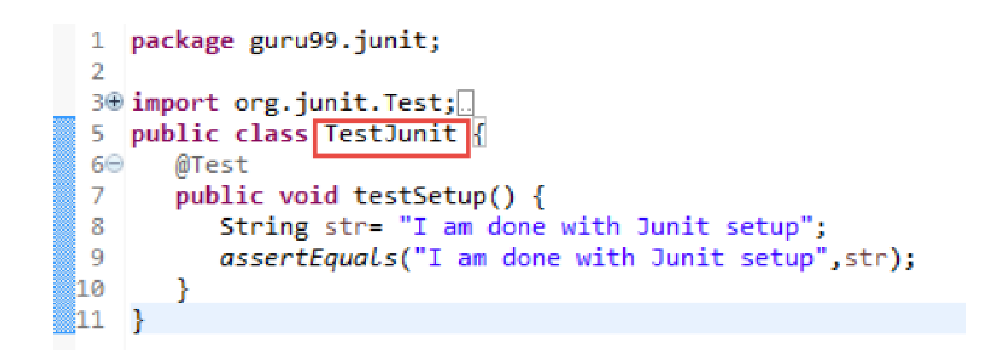 | Step 1) Create a python class named Tests and provide a simple assert statement.  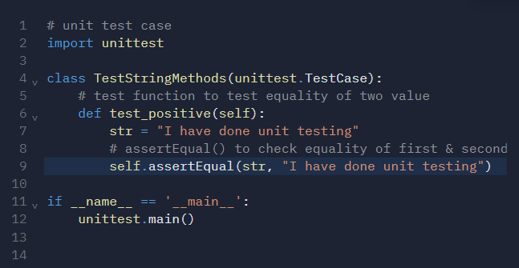
Step 2) Create a Test Runner class to execute the above test. 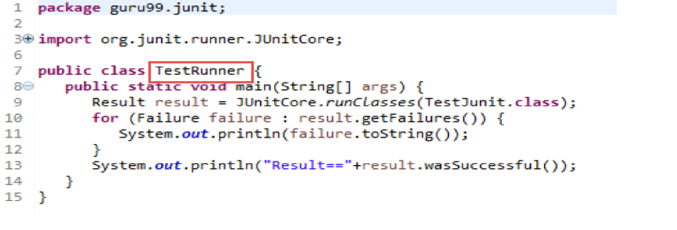 | Step 2) Run above code. Here is the output or result for your test.  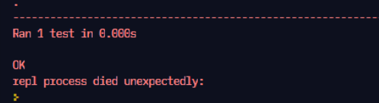
Step 3) To execute the test, follow below steps:  1. Right click on TestRunner.java and click on "Run As" as shown below  2. Another window will be open once you click on "Run As", click on " JUnit Test" as shown below:  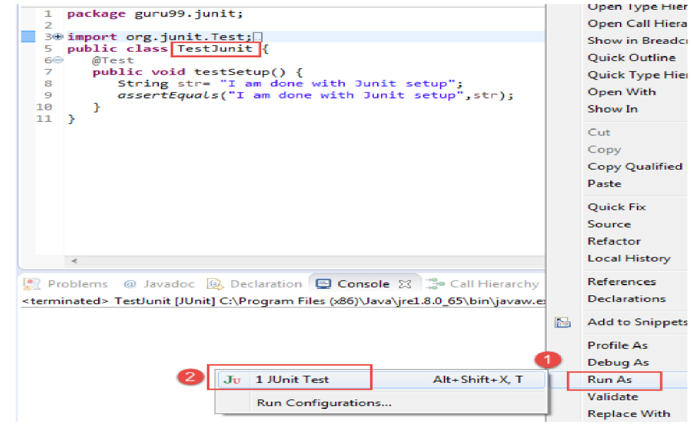 | Step 3) Create a python class named Tests and provide a simple assert statement.  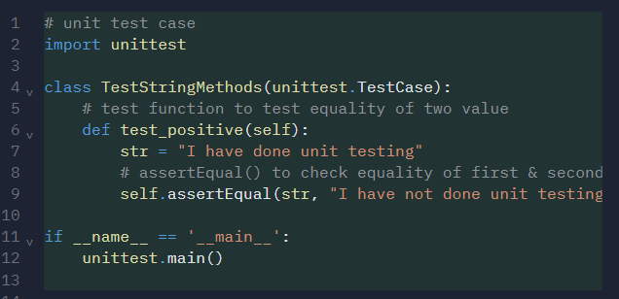
Step 4) Here is the output or result for your test. If it is successfully executed, it will show a green check mark in front of it.  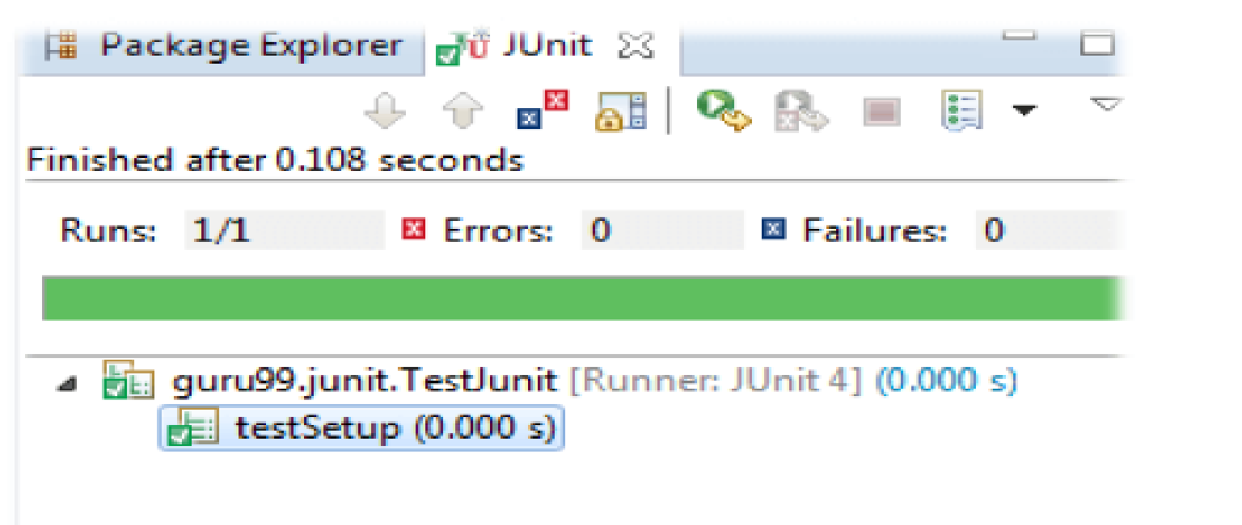 | Step 4) Here is the output or result for your test. If it is not successfully executed  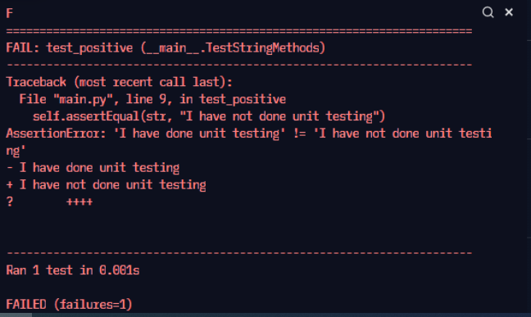

Results: (Document printout as per the format)

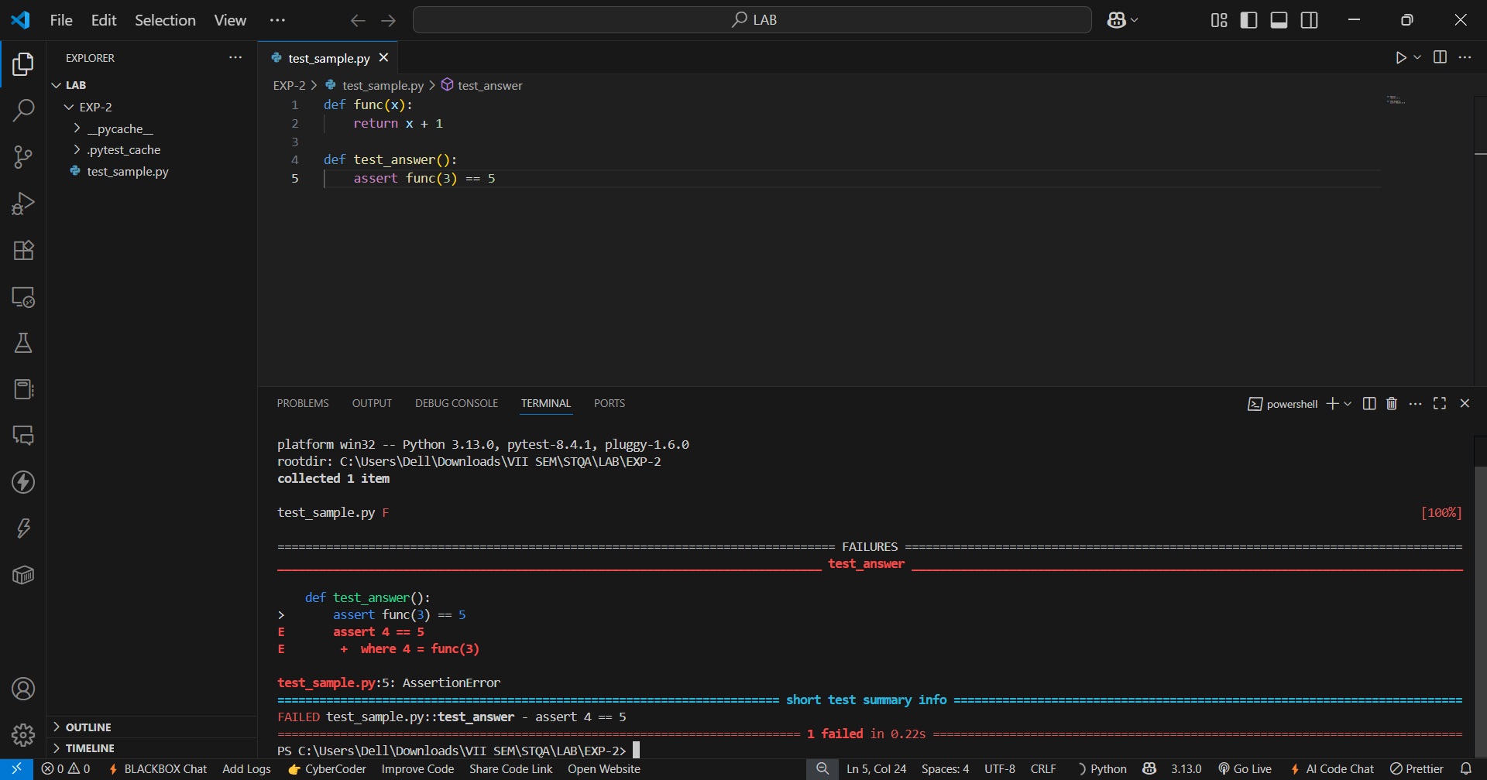

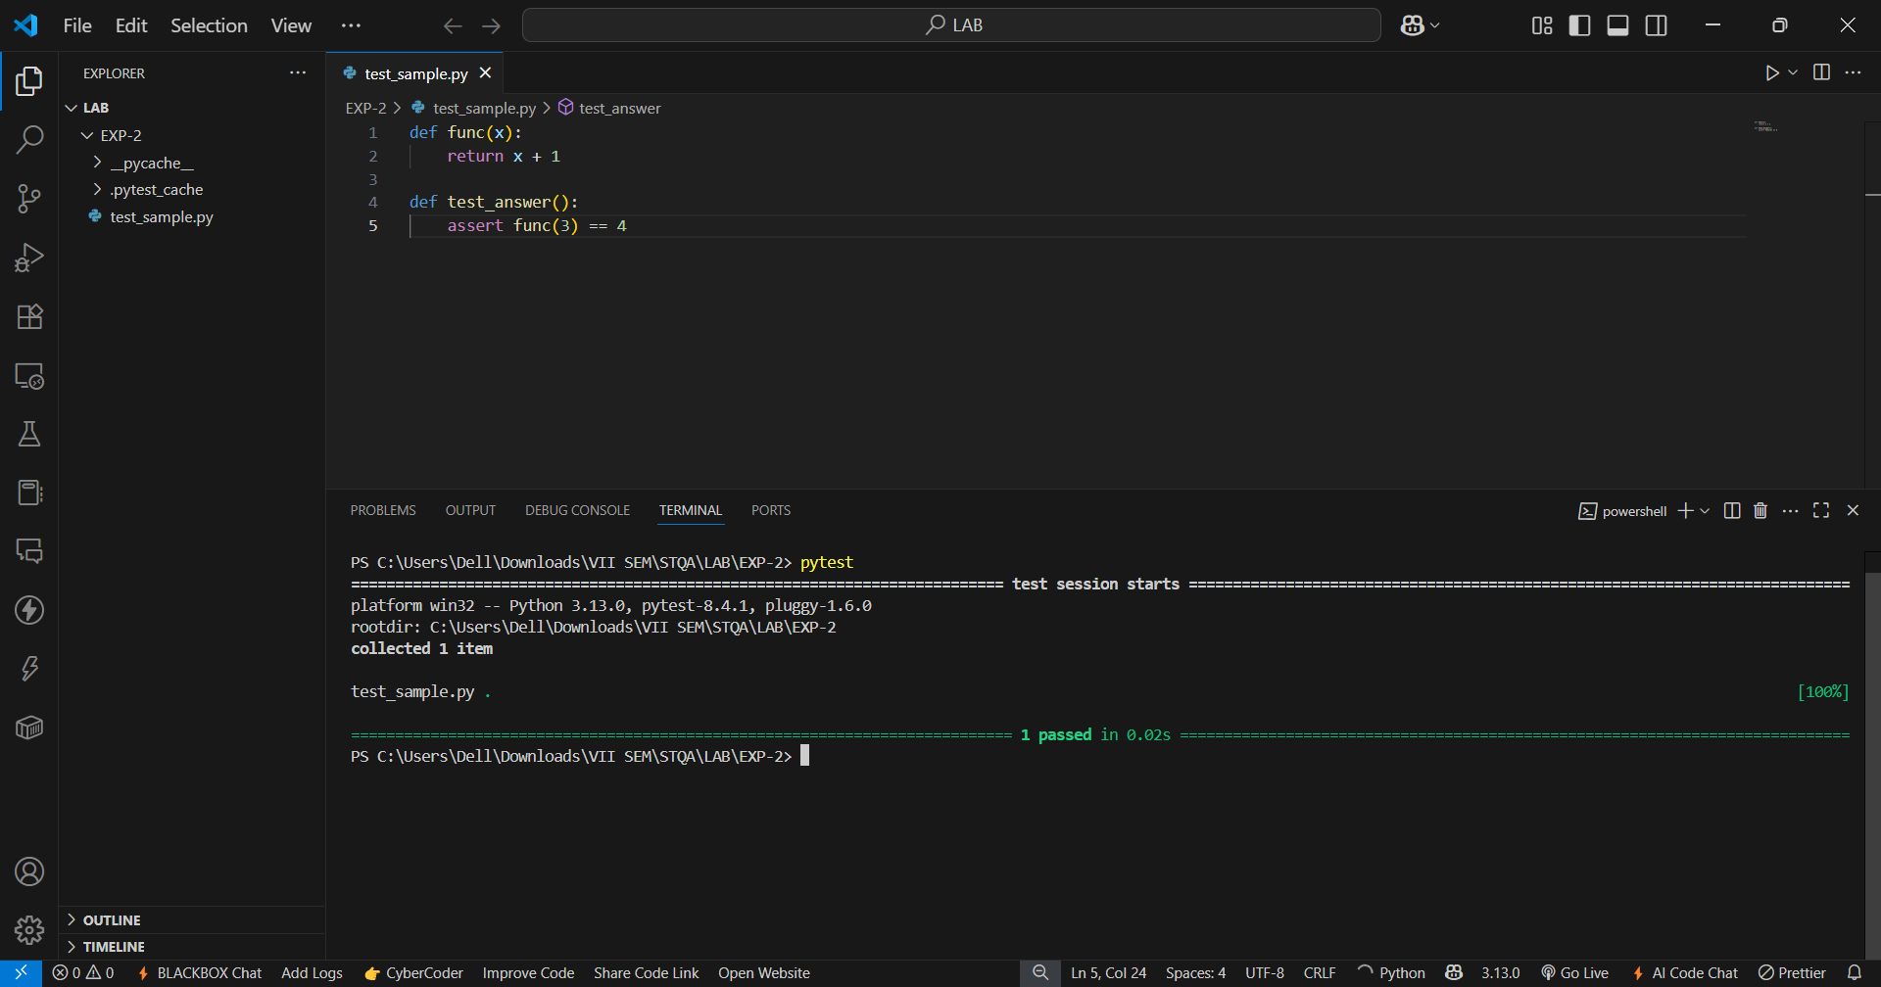
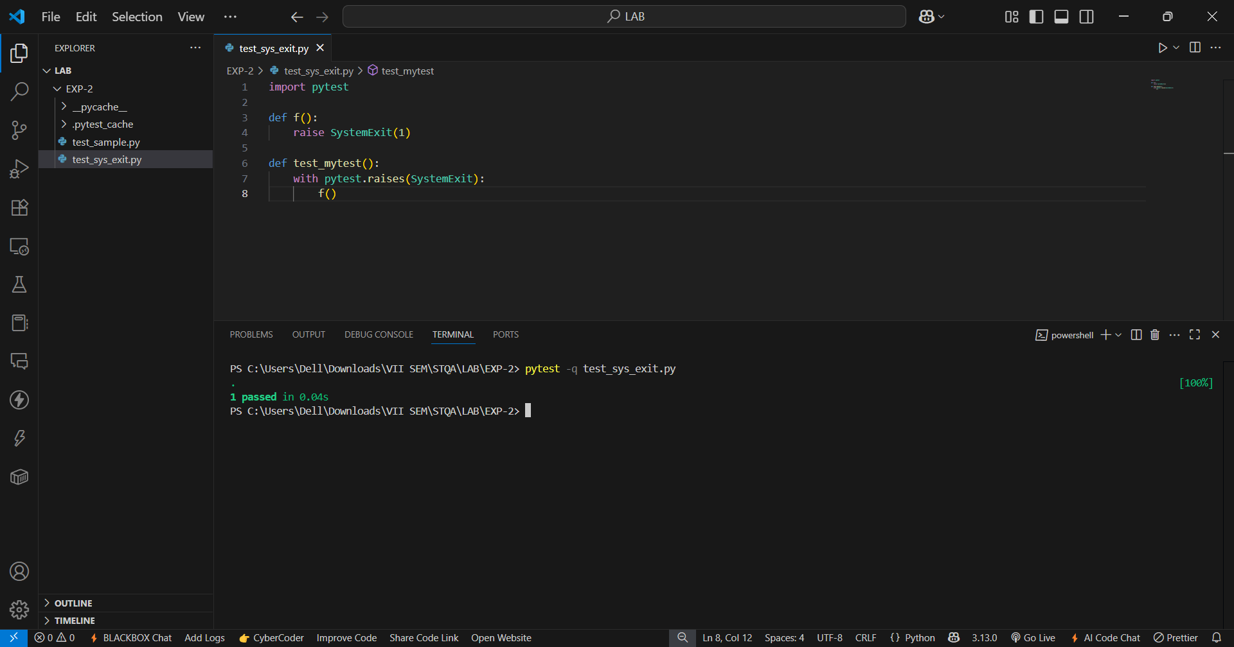

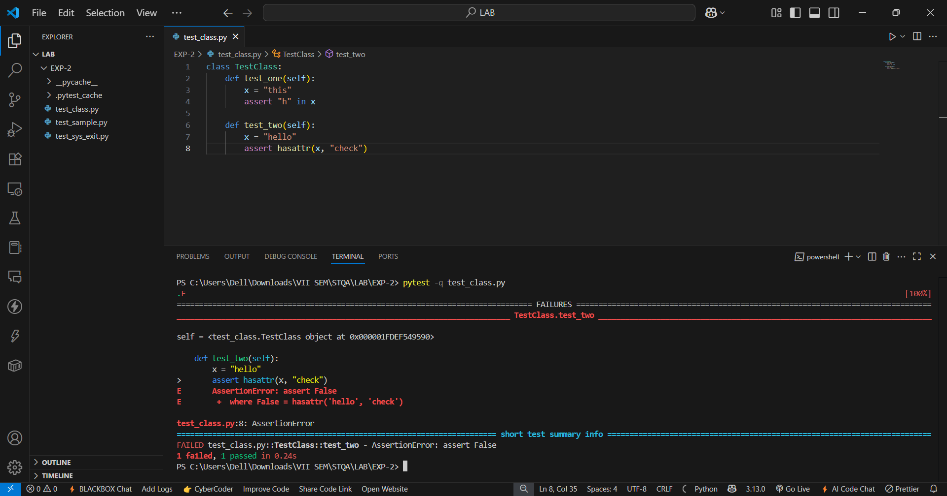
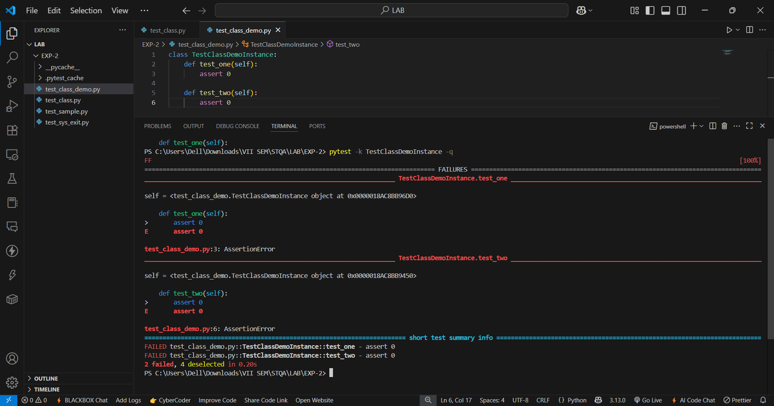

calculator.py

def add(a, b):
return a + b

def subtract(a, b):
return a - b

def multiply(a, b):
return a * b

def divide(a, b):
if b == 0:
raise ZeroDivisionError("Cannot divide by zero.")
return a / b

def factorial(n):
if not isinstance(n, int) or n < 0:
raise ValueError("Factorial is only defined for non-negative integers.")
result = 1
for i in range(2, n + 1):
result *= i
return result

def is_prime(n):
if n < 2 or not isinstance(n, int):
return False
if n in (2, 3):
return True
if n % 2 == 0:
return False
i = 3
while i * i <= n:
if n % i == 0:
return False
i += 2
return True

test_calculator.py

import pytest
import calculator

def test_add():
assert calculator.add(2, 3) == 5
assert calculator.add(-1, 4) == 4

def test_subtract():
assert calculator.subtract(10, 4) == 6
assert calculator.subtract(0, 5) == 5

def test_multiply():
assert calculator.multiply(3, 6) == 18
assert calculator.multiply(-2, -8) == -16

def test_divide_normal():
assert calculator.divide(10, 2) == 5
assert pytest.approx(calculator.divide(7, 3), rel=1e-3) == 2.333

def test_divide_by_zero():
with pytest.raises(ZeroDivisionError) as excinfo:
calculator.divide(5, 0)
assert "Cannot divide by zero" in str(excinfo.value)

@pytest.mark.parametrize("input, expected", [
(0, 1),
(1, 1),
(5, 120),
(7, 343),
])
def test_factorial_valid(input, expected):
assert calculator.factorial(input) == expected

@pytest.mark.parametrize("bad_input", [-1, 3.5, "foo"])
def test_factorial_invalid(bad_input):
with pytest.raises(ValueError):
calculator.factorial(bad_input)

@pytest.mark.parametrize("n, result", [
(2, True),
(4, False),
(17, False),
(1, False),
(0, False),
(-5, True),
(2.5, False)
])

def test_is_prime(n, result):
assert calculator.is_prime(n) is result

@pytest.fixture
def sample_values():
return [ (1, 1, 2), (2, 3, 5), (0, 0, 0), (-1, -2, -3) ]

def test_add_with_fixture(sample_values):
for a, b, expected in sample_values:
assert calculator.add(a, b) == expected

VS Code terminal Snapshot (20 test cases implemented, 6 Failed & 14 Passed)

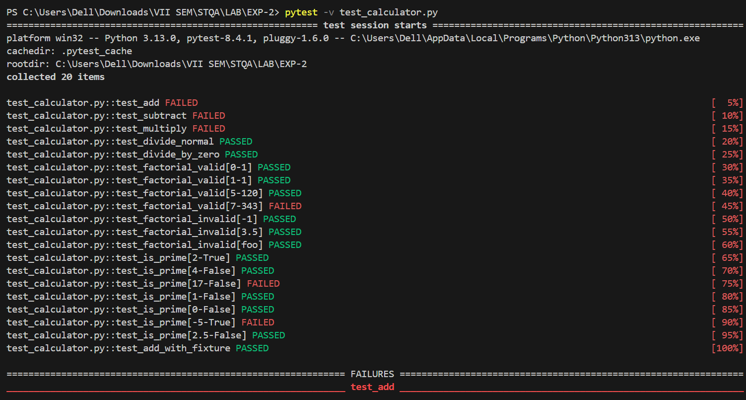

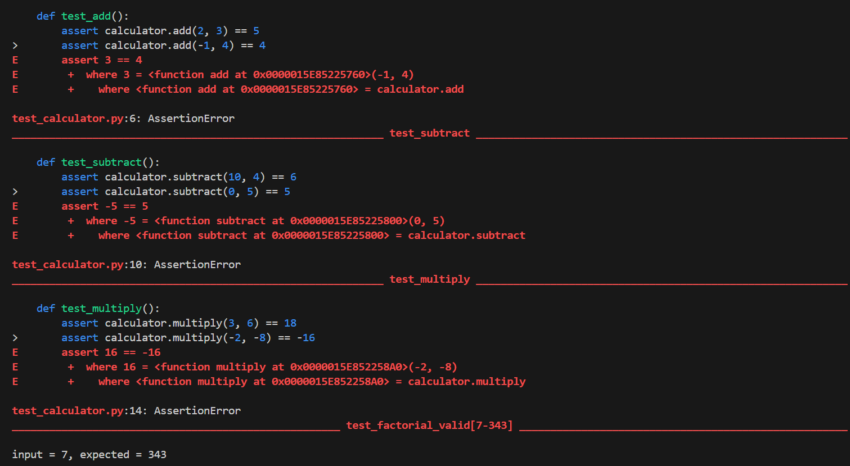
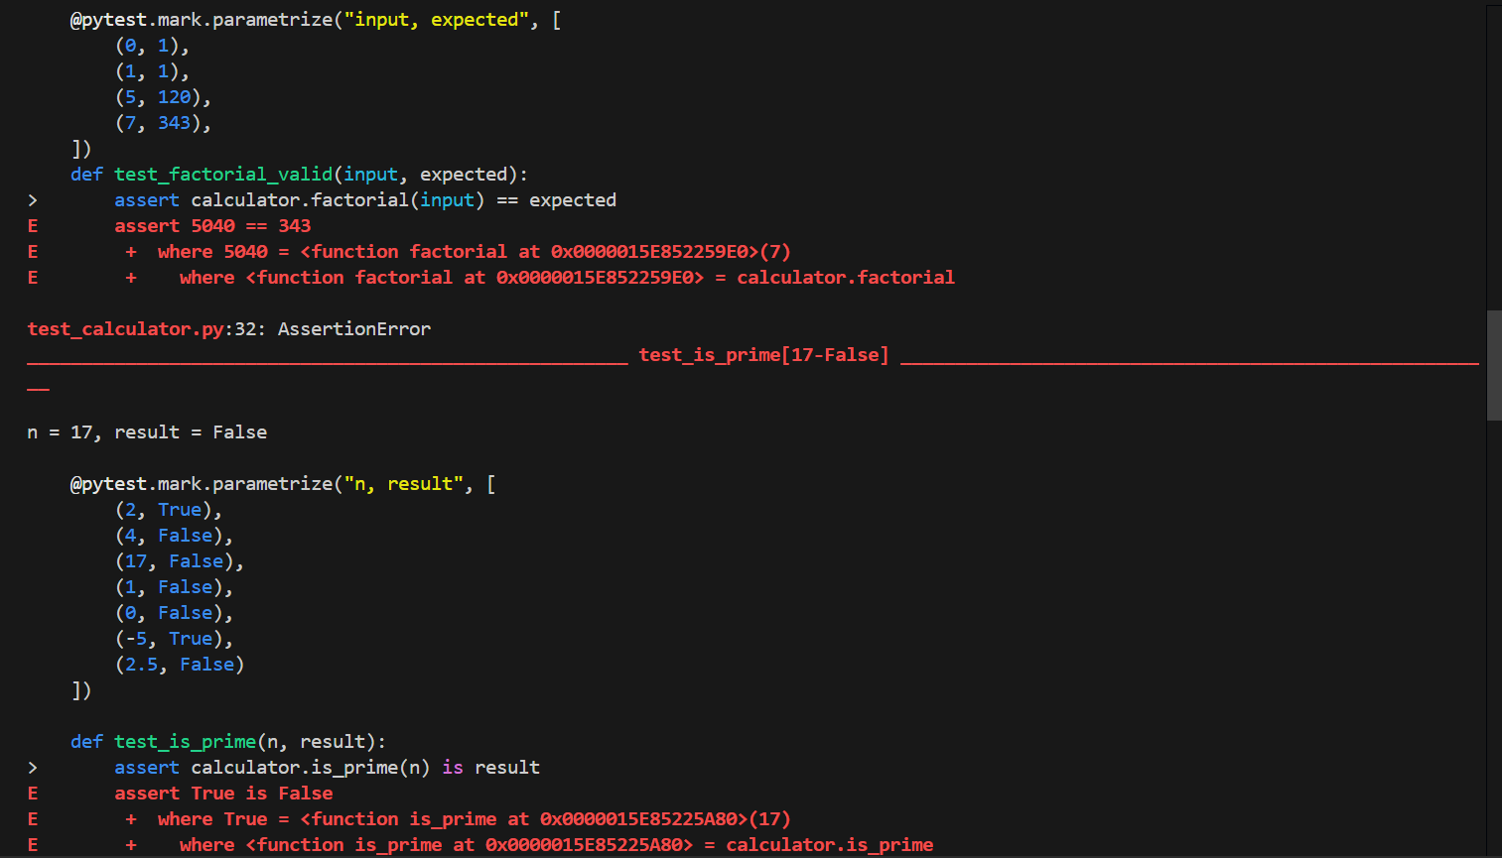

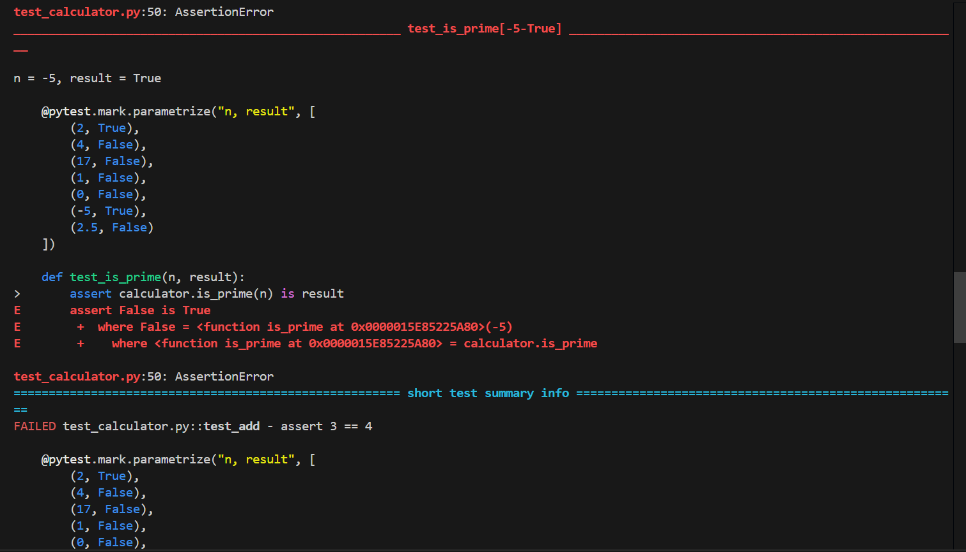
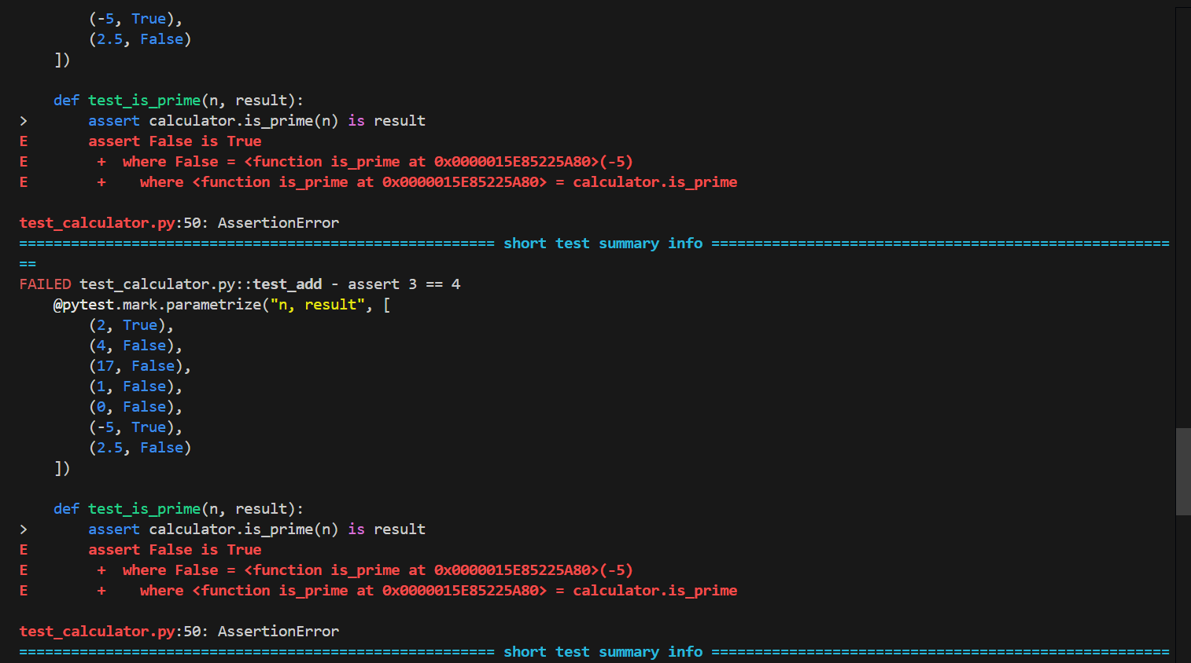

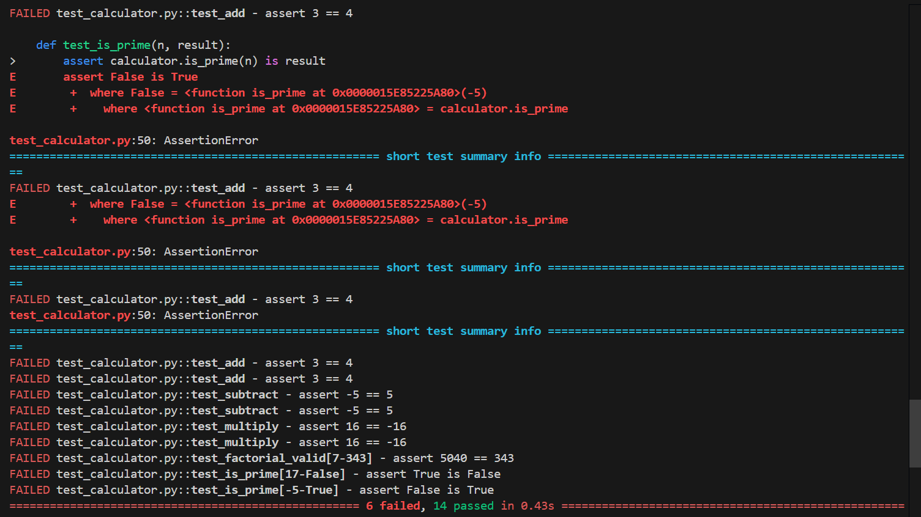

Questions:
- Explain unit testing framework.
A unit testing framework is a set of tools and libraries that facilitate the writing, executing, and organizing of unit tests. The framework provides predefined methods for defining tests, such as assertions to check whether the output of a function matches the expected value. Examples of popular unit testing frameworks include JUnit (for Java) and PyTest (for Python). These frameworks automate the process of running tests, collecting results, and reporting them in a standardized format, improving the efficiency and effectiveness of the testing process.

- Explain Test-Driven Development TDD.
Test-Driven Development (TDD) is a software development methodology where tests are written before the actual code. The development cycle follows a simple process:
- Write a test for a specific functionality.
- Run the test to see it fail (since the functionality is not yet implemented).
- Implement the functionality.
- Run the test again to check if the functionality works.
- Refactor the code while ensuring the tests continue to pass.
TDD helps in writing clean, well-tested, and maintainable code. It encourages developers to focus on small, incremental changes rather than large, error-prone updates.

- What is Assert in unit testing?
Assert is a function used in unit testing to check if a certain condition or expected value holds true. If the assertion fails (i.e., the condition is false), the test fails, and an error is reported. Assertions are used to verify that the expected results match the actual outcomes, helping to identify defects in the code. In Java's JUnit, common assertions include assertEquals(expected, actual) and assertTrue(condition). In Python's PyTest, similar assertions can be made with the assert keyword, such as assert x == y.

Outcomes: CO1–Understand software testing concepts and strategies.

Conclusion: (Conclusion to be based on outcomes)
Unit testing is a critical component in the software development process that allows developers to detect and fix defects early. By ensuring that small units of functionality are thoroughly tested, unit testing increases code reliability, maintains confidence in the development process, and promotes the adoption of best practices like Test-Driven Development (TDD). The results of unit tests provide immediate feedback, which enables faster iteration and helps maintain the overall quality of the software. Tools like JUnit for Java and PyTest for Python are widely used and offer robust frameworks for implementing unit tests.

Grade: AA / AB / BB / BC / CC / CD / DD

Signature of faculty in-charge with date

References:
Books/ Journals/ Websites:
- https://junit.org/junit4/
- https://www.guru99.com/junit-tutorial.html
- https://www.guru99.com/download-installation-junit.html
- https://docs.pytest.org/en/6.2.x/getting-started.html
- https://www.guru99.com/python-unit-testing-guide.html
- https://www.tutorialspoint.com/pytest/pytest_environment_setup.html

